KELİMELER
- Long Range= Uzun Mesafe
- Device=Cihaz
- Extremely= Son derece
- Release= Serbest bırakmak
- Processor= İşlemci
- Accelerator=Gaz pedalı
- implement= uygulamak
- instruction= talimat
- prefetch =önceden getirme
- queue= sıra
- execution =uygulama
- manufacture=üretim
- require=gerektirmek
- facilitate =kolaylaştırmak
- unaligned = hizalanmamış
- integration =entegrasyon
- reduce=azaltmak
- Thread = Konu
- privileged= ayrıcalıklı
- stack = yığın

- two USART (supporting LIN, smartcard, IrDA, modem control and ISO7816)
- one low-power UART (LPUART)
- three I2C (SMBus/PMBus)
- two SPIs (up to 16 MHz, one supporting I2S)
- semaphores for processor firmware process synchronization

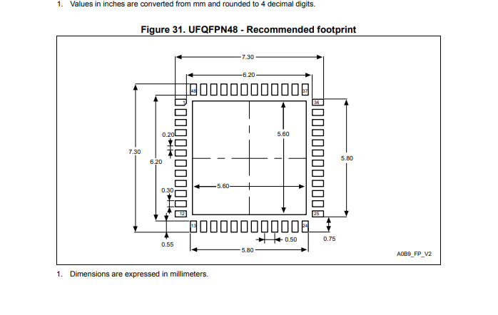
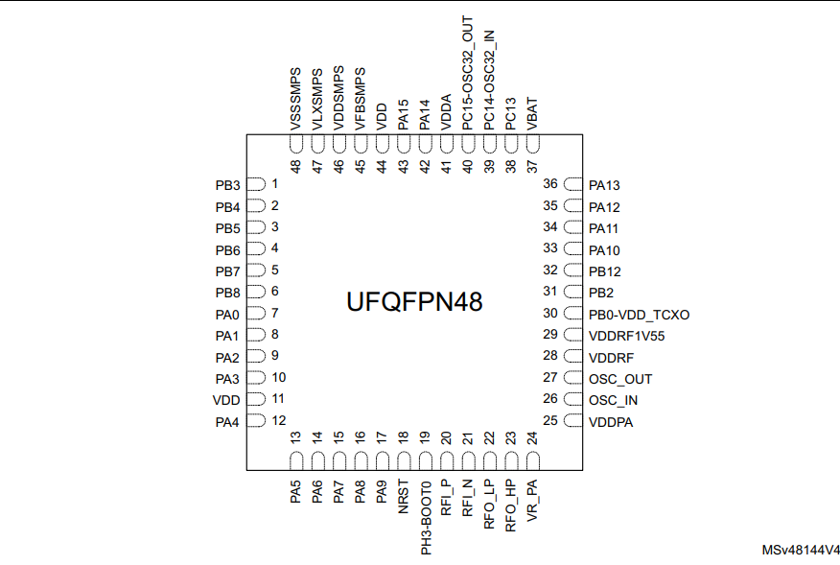

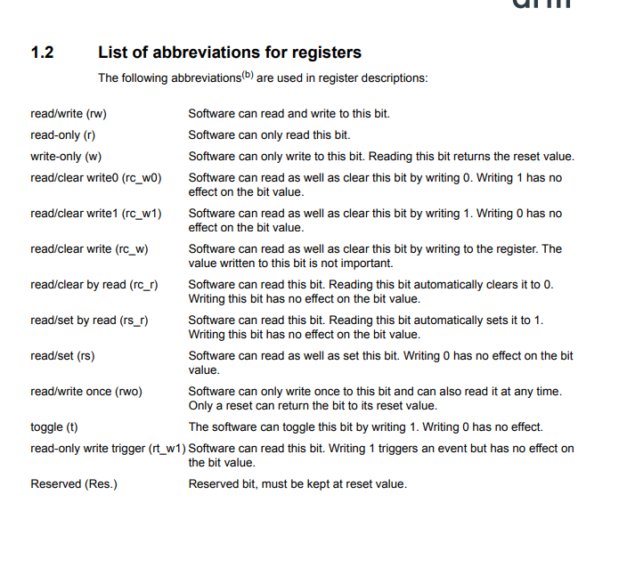

This section gives a brief definition of acronyms and abbreviations used in this document:
• Word: data of 32-bit length.
• Half-word: data of 16-bit length.
• Byte: data of 8-bit length.
• Option bytes: product configuration bits stored in the Flash memory.
• AHB: advanced high-performance bus.

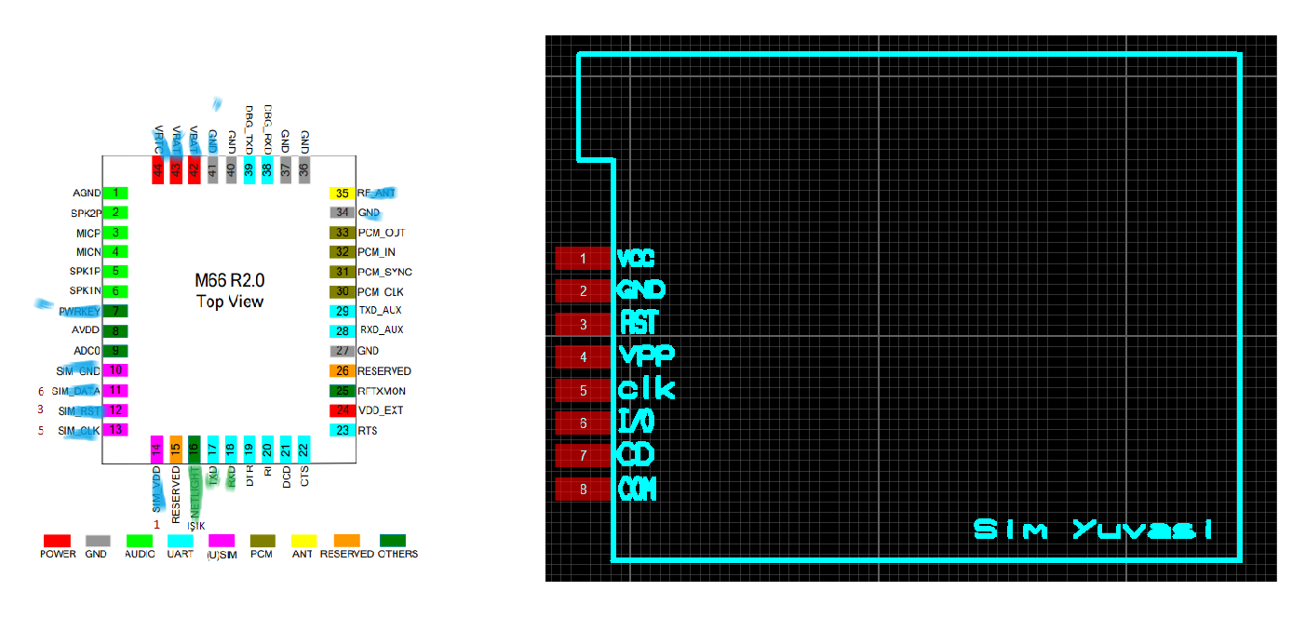
https://www.alibaba.com/product-detail/ESP8266-ESP-01S-ESP01S-WiFi-Serial_60838837702.html

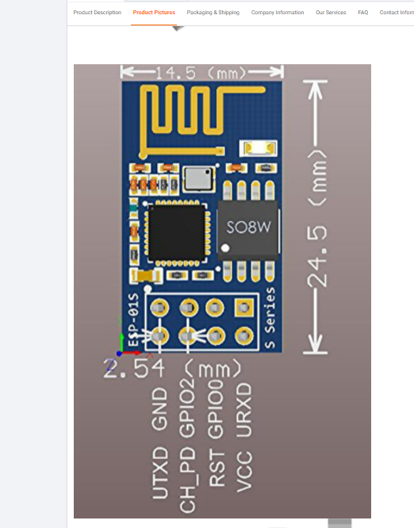

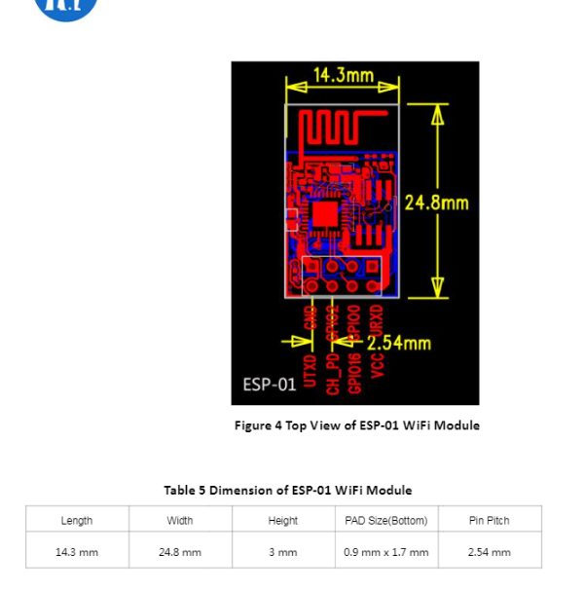
https://pdf1.alldatasheet.com/datasheet-pdf/view/1179098/ETC2/ESP-01.html

